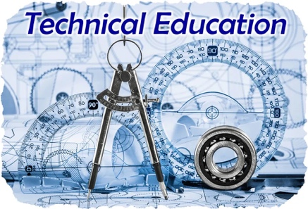
Preventative Maintenance Schedule

Program Name:___________________________________
High School:______________________________________
Year: ___________________________________________
Machines/Equipment should be checked routinely for problems and maintenance needs.
Please send maintenance request if a deficiency is found.

Instructor initials indicate the equipment was checked.
- Change the equipment list to match your lab needs. If equipment costs less to repair than to replace, it should be on the list.
- Consider allowing a student assigned as the lab manager to do the initial check and follow up with your own check of the equipment.
- You may adjust to check equipment more frequently if needed.
- You can keep this posted in the lab as visible documentation throughout the school year and upload a copy to the Google Classroom annually.

Equipment | 1st Semester  Date | Checked By: | 2nd Semester  Date | Checked By:

